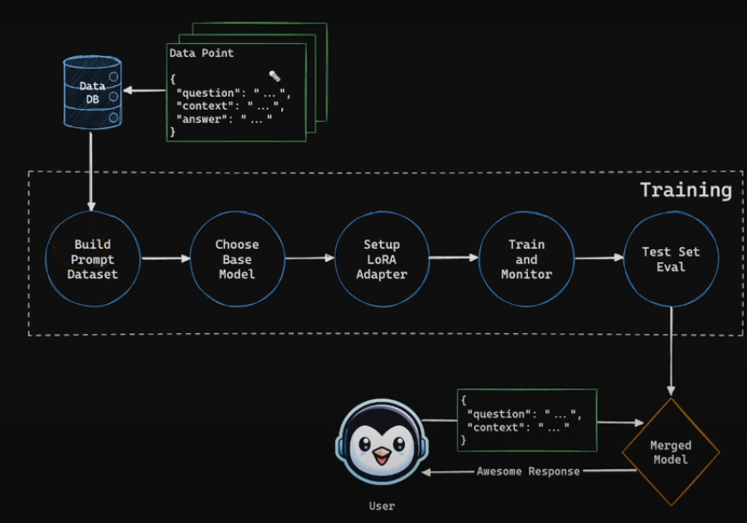

2- Use OpenAI API to Create Custom QA Dataset
{"question":"..."
"context":"..."
"answer":"..."}
3-PEFT Fine Tune Llama 3.1 4-bit Base and Llama 3.1 4-bit Instruct

1- Collect Jordanian Laws and Extract Articles

5-Ready Fine-Tuned Models

4-Qualitative and Quantitative Evaluation for Base and Fine-Tuned Models

6-Use Models in Arabic Legal RAG Applications

